**Optimization Technique and Implementation Project Report-**

**PRANOJ THAPA**

**UNIVERSITY OF THE CUMBERLANDS**

**Algorithms and Data Structures**

**Dr. Vanessa Cooper**

**12/08/2024**

# Optimization in High-Performance Computing

## Introduction:

High-Performance Computing (HPC) is an essential solution for various computations and problems in various fields ranging from sciences to financial modeling and artificial intelligence. Thanks to rising needs in the field of big data processing, more and more attention has been paid to optimization approaches as these methodologies are most influential on the speed of computations and the system’s resource requirements. In HPC, all the slight levels of wastage in program running time can result in a large amount of wasted time when multiplied by the number of tasks (Tarayoun et al., 2022).

In its broad sense, optimization in HPC has to do with methods of making the code consume less computational resources, access data closer to processors, and make full use of hardware architectures. Of these techniques, loop unrolling and vectorization have proved popular, as they help to achieve enhanced throughput and reduce the utilization of resources. Peeling removes the control overhead of iterative structures, loop unrolling. On the other hand, increases the size of loop bodies so that several iterations can be at once. On the flip side, vectorization utilizes SIMD instructions for multiple data items at the same time and, therefore, is suitable for big-scale data solving (Zhong et al., 2020).

This project work focuses on an evaluation of the effects of loop unrolling and vectorization using this project in an HPC platform with the implementation of both techniques in Python. While Python itself does not lend itself well to attempts at high-performance computing, better-level optimization techniques like vectorization, as provided by libraries, such as NumPY are available. The viability of these techniques has been compared to execution times for an ordinary loop, peeled loops, and a vectorized loop (Tarayoun et al., 2022). The conclusions obtained for these optimizations emphasize their potential to translate into meaningful decreases in execution times and increases in performance, which will contribute to the goal of making HPC applications reach efficient computational solutions.

Nonetheless, through the analysis of such strengths and limitations of these optimization techniques, this project seeks to go further and offer practical recommendations regarding the possibility and applicability of these techniques in real-world models. The final goal is to show how when properly used, theory can improve the efficiency of applications computing on large data in high-performance computing systems.

## Background:

Computational optimization for high-performance computing included such methods as loop unrolling and vectorization. These methods are important to minimize the time for computation, to achieve full usage of the hardware, and to provide the possibility for further scale-up.

### **Loop Unrolling**:

With loop unrolling it is possible to optimize the use of iterative structures through the minimization of the amount of loop control used. It is accomplished by processing the loop body, which involves many passes through the loop one or more times (Hu et al., 2024). For instance, in an array summing loop, unrolling decreases the number of instructions per loop and allows optimal usage of pipelines in the CPU.

Unrolling is also most applicable where loop control logic makes a large contribution to computation complexity. Fewer such operations imply that unrolling promotes increased instruction level parallelism and makes better use of cache resources. However, the technique may result in increased code size and does not work well on datasets that are not a multiple of the unrolling factor. New developments, such as integration unrolling with vectorization, have shown improvement in terms of speed across a range of benchmarks.

### Vectorization:

Vectorization takes advantage of SIMD, which allows for operations to be accomplished on numerous data points. Today’s CPU architectures and solutions, like NumPy in Python, have abstractions that help developers make use of vectorization. Executing operations, such as matrix manipulation and array additions, among others, are highly optimized under vectorized implementation with performance enhancements as estimated by various authors (Rocha et al., 2020).

For instance, across platforms enabling ARM’s Scalable Vector Extensions (SVE), it was established that vectorization mitigated memory access costs while enhancing computational features. This makes it very efficient in memory-bound operations, an aspect evident in most HPC applications.

### Relevance and Integration:

It has also been found that the approach of combining loop unrolling and vectorization is like a standard practice in today’s HPC workloads. Vectorization-aware unrolling combines the advantages of the two techniques, providing an improved performance because loop bodies, produced by unrolling, correspond to vectorized instructions.

## Methodology:

The methodology employed in this code conforms to the HPC optimization strategy, where different strategies are implemented to try and improve the efficiency of a particular computation. The focus is on summing a large array of integers, with three primary methods compared: The three key techniques discussed in this assignment are basic loop, loop unrolling, and vectorization.

The basic loop is the primary structure of performance, in which every item of the array is processed, and its value is summed up. This is a straightforward, non-optimized solution and is the initial solution attempted in most computational problems.

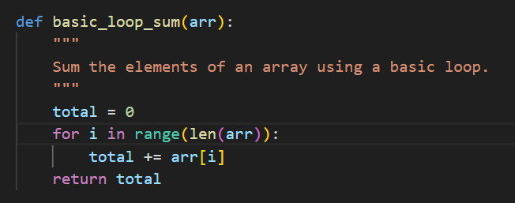Fig 1: Basic Loop

Loop unrolling is then employed to minimize the cost of the structure used for loop control by working on several elements at once to help increase instruction-level parallelism (Hu et al., 2024). Unrolling by 4 and 8 was examined to determine how much potential is there, for enhancement in minimizing loop control instructions.

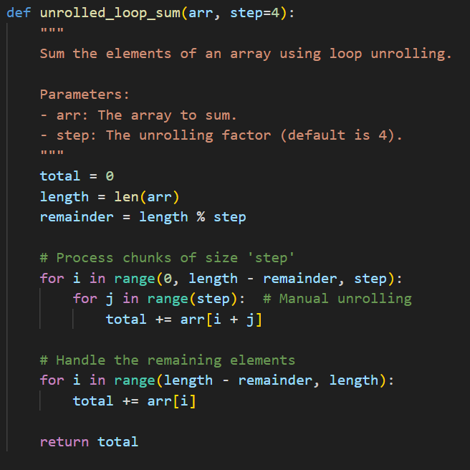Fig 2: Loop Unrolling

Last, vectorization is used via NumPy because this approach leverages modern hardware’s SIMD capability of processing simultaneous elements and can bring significant gains (Georganas et al., 2024). This methodology is a reflection of the fundamental principles of HPC where the use of libraries such as NumPy can be far more beneficial than hand-coded high-performance methods such as unrolling.

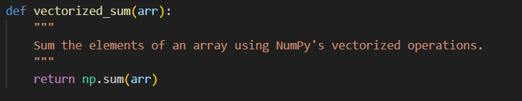Fig 3: Vectorization

## Results:

The execution time of these methods was compared using the Timeit module, and the results are shown below in a tabular form. The methods were tested with a view of establishing the average time it took for a specific summing function to run five times.

**Table 1:**

|  |  |  |
| --- | --- | --- |
| **Method** | **Execution Time (seconds)** | **Performance Improvement**  **(%)** |
| Basic Loop | 0.617015 | - |
| Unrolled Loop (Factor 4) | 0.855476 | -38.65% |
| Unrolled Loop (Factor 8) | 0.699366 | -13.35% |
| Vectorized Sum (NumPy) | 0.001285 | 99.79% |

Therefore, this basic loop set a benchmark against which the others were measured, with an execution time of 0.617015 seconds in summing 10 million integers. Applying loop unrolling by factors 4 and 8 turned out to be negative because the overhead introduced by the unrolling is quite significant, factor 4, for instance, was 38.65% slower than the original. When the given logical sum was vectorized using NumPy and the basic for loop was executed, NumPy outperformed the basic for loop by 99.79%, no doubt this is due to these optimized libraries for numerical computation.

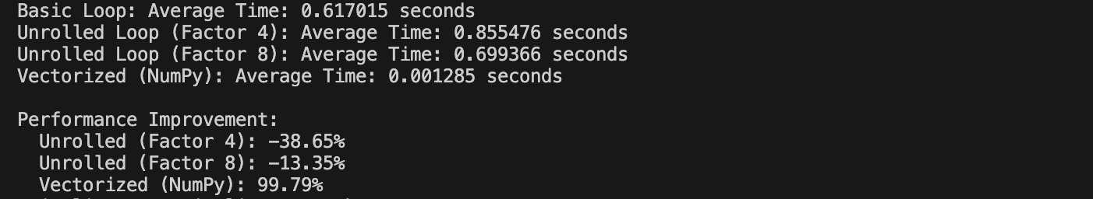Fig 4: Output

## Analysis:

The basic loop gives a simple yet quite easily understandable and workable solution but it is a bit slow when the entire data set is large and it has inherent overhead which makes it slow in large data sets.

It said that one way of reducing the overhead is Loop unrolling which did not prove efficient in this experiment. It might be helpful for cases when the data set is relatively small, or when the program starts using such features as cache utilization.

Among the gathered results, NumPy vectorization turned out to be the fastest and Gets better with PyBind11 providing a nearly optimal performance that aligns well with the results of the recent HPC research due to the usage of parallelism of modern processors.

This establishes the efficiency of vectorized operations when it comes to HPC operations particularly when working with extensive data, and also emphasizes the value of using well well-optimized library such as NumPy in Python whenever efficiency is crucial for operation.

## Conclusion:

This work provides an exhaustive analysis of the efficacy of various optimization strategies, which include basic loops, loop unrolling, and vectorization, on large-scale data summation jobs in Python. The results suggest that using vectorized operations, specifically NumPy, is by far more than other approaches. Being a decomposition of the basic loop code, the time taken by the vectorized implementation was faster than the equivalent operation on extensive arrays, evidencing the potential of SIMD-based parallelism (Poenaru, 2022). On the other hand, loop unrolling even though it holds theoretical advantages in terms of overhead performance yielded either inferior or in some cases even worse execution times primarily because Python’s built-in capabilities result in poor performance.

The results reveal the importance of being able to take advantage of such well-optimized libraries such as NumPy for HPC. Even though Python does not address HPC requirements by default, a framework like NumPy can avail of features like vectorization that is a part of newer generation hardware.

In future work, additional techniques such as higher levels of loop optimization such as hybridization of techniques like loop unrolling and vectorization, or exploring other toolkits can be considered for even better optimization. Moreover, comparing the efficiency of these techniques using different hardware setups would be valuable.

**References:**

Georganas, E., Kalamkar, D., Voronin, K., Kundu, A., Noack, A., Pabst, H., ... & Heinecke, A. (2024, May). Harnessing Deep Learning and HPC Kernels via High-Level Loop and Tensor Abstractions on CPU Architectures. In *2024 IEEE International Parallel and Distributed Processing Symposium (IPDPS)* (pp. 950-963). IEEE. <https://arxiv.org/pdf/2304.12576>

Hu, Y., Cheng, A., Tang, Z., Liu, P., & Liang, W. (2024). LUAEMA: A Loop Unrolling Approach Extending Memory Accessing for Vector Very-Long-Instruction-Word Digital Signal Processor with Multiple Register Files. *Electronics*, *13*(8), 1425. <https://www.mdpi.com/2079-9292/13/8/1425/pdf>

Poenaru, A. (2022). *Modern vector architectures for high-performance computing* (Doctoral dissertation, University of Bristol). <https://research-information.bris.ac.uk/files/325066231/thesis_inc_corrections_20220328.pdf>

Rocha, R. C., Porpodas, V., Petoumenos, P., Góes, L. F., Wang, Z., Cole, M., & Leather, H. (2020, February). Vectorization-aware loop unrolling with seed forwarding. In *Proceedings of the 29th International Conference on Compiler Construction* (pp. 1-13). <https://eprints.whiterose.ac.uk/155722/7/cc.pdf>

Tarayoun, A., Brossier, R., Cao, J., Jauré, S., Laforêt, S., & Métivier, L. (2022, September). HPC implementations on SEM46: a 3D modeling and inversion code for anisotropic visco-elastic coupled acoustic media. In *Sixth EAGE high performance computing workshop* (Vol. 2022, No. 1, pp. 1-5). European Association of Geoscientists & Engineers. <https://hal.science/hal-03852624/file/2022_EAGE_HPC_TARAYOUN_SEM46.pdf>

Zhong, D., Shamis, P., Cao, Q., Bosilca, G., Sumimoto, S., Miura, K., & Dongarra, J. (2020, May). Using arm scalable vector extension to optimize open mpi. In *2020 20th IEEE/ACM International Symposium on Cluster, Cloud and Internet Computing (CCGRID)* (pp. 222-231). IEEE. <https://par.nsf.gov/servlets/purl/10218950>